**TEAM MA12 ECO-CULT**

**CARBCON WEB APP**



Deployment Documentation

Table of Contents

1. Introduction 2

2. System Setup and Technical Requirements 2

3. EC2 Instance and SSH setup 2

4. Setup Database. 3

5. Setup Domain and DNS 5

6. Install WordPress on Amazon EC2 Ubuntu 6

7. Digital Ocean Droplet Deployment 10

# **Introduction**

This documentation focuses on CarbCon web app system deployment . In detail, the report contains EC2 instance deployment along with MySQL, Wordpress and Apache setup on ubuntu. It also covers the domain and DNS setup for the website and digital ocean droplet deployment for instance migration in the final iteration.

# **System Setup and Technical Requirements**

|  |  |
| --- | --- |
| **System** | **Description** |
| Operating System | Ubuntu 18.04.01 |
| EC2 Instance | Type: t2.micro  Security Group: Custom – Defined  AMI ID: 099720109477/ubuntu/images/hvm-ssd/ubuntu-bionic-18.04-amd64-server-20200810 (ami-0f87b0a4eff45d9ce) |
| AWS EC2 | Server Hosting |
| PuttyGen | Generate private key for SSH connection |
| Apache 2.4 Web | Web server software |
| Wordpress Version 5.5.1 | Web management system |
| HTML | Web development tool |
| MySQL 5.7 | Database management system |
| AWS Route 53 | DNS management system |
| Cloudfare | DNS Security system |
| Get.tech | Tech domain registration |

# **EC2 Instance and SSH setup**

* Create AWS account as root user
* Create EC2 instance by selecting Ubuntu Server
* 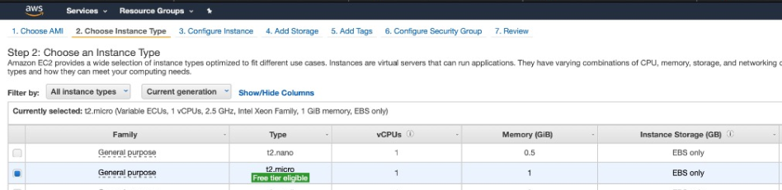Choose the instance type t2.micro
* Configure the EC2 instance as follows
* 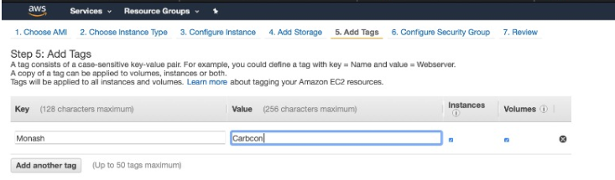Setup EC2 instance inbound and outbound rules as follows

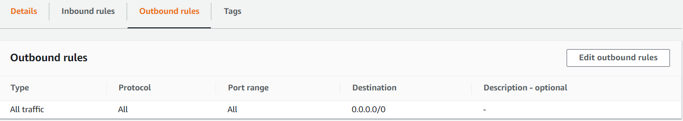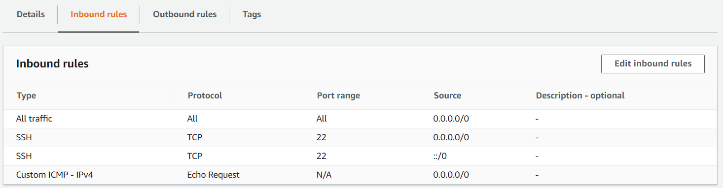

* Download the privatekey ppk file and generate pem with putty gen
* To access the EC2 instance SSH using local terminal with pem file and instance address as follows

# **Setup Database.**

* Update Package and Install MySQL

**sudo apt update**

**sudo apt install mysql-server**

* Configure MySQL

**sudo mysql_secure_installation**

* Set MySQL user authentication

**sudo mysql**

**ALTER USER 'root'@'localhost' IDENTIFIED WITH mysql_native_password BY 'password';**

**FLUSH PRIVILEGES;**

* Login to the MySQL

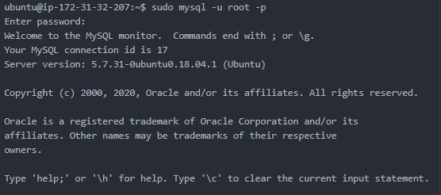

* Query the global secure file folder and upload csv data to the directory from local computer

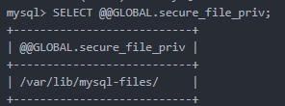

* Display the database list and change the database to carbcon

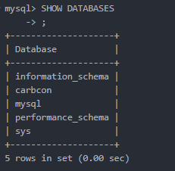



* Create the database by loading the carbcon.csv data

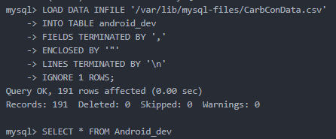

# **Setup Domain and DNS**

* 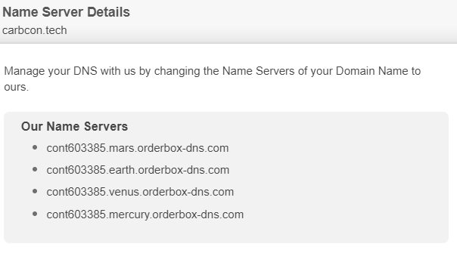Obtain the domain name through get.tech and get the nameserver information
* Create hosted zone using AWS route 53 and set the nameserver as follows

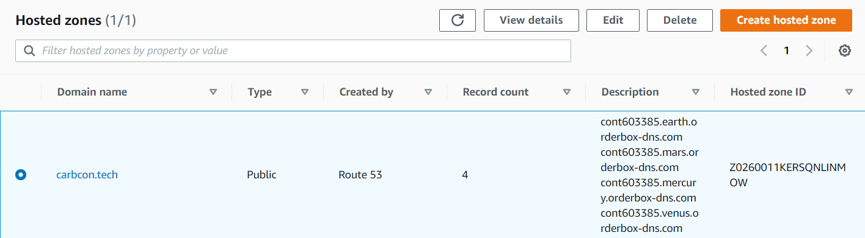

-

* Create cloudflare account and setup the DNS management using the nameserver and EC2 instance IP address
* 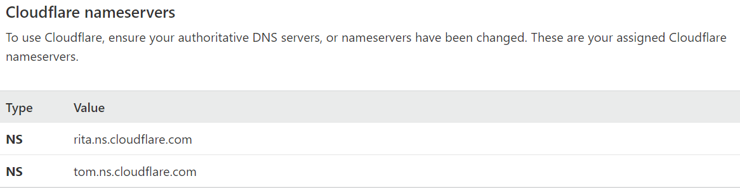Generate cloudflare nameservers as follows
* 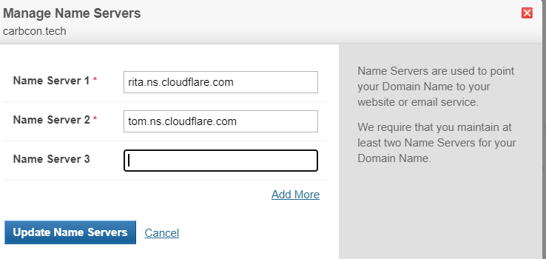Replace nameserver in get.tech with cloudlfare nameservers as follows
* Enable the HTTPS in the cloudflare DNS setting

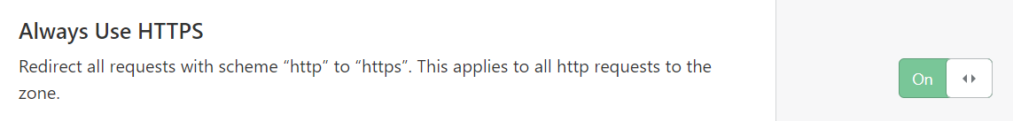

# **Install WordPress on Amazon EC2 Ubuntu**

* Install WordPress on Amazon EC2 Ubuntu

**ssh -i cbc.pem** [**ubuntu@ec2-3-24-214-128.ap-southeast-2.compute.amazonaws.com**](mailto:ubuntu@ec2-3-24-214-128.ap-southeast-2.compute.amazonaws.com)

* Install Apache 2.4 Web in the EC2 instance

**sudo add-apt-repository ppa:ondrej/apache2**

* Update system repository to install available upgrade packages

**sudo apt update**

* Install Apache package

**sudo apt-get install apache2 -y**

* Install PHP 7.2 for WordPress

**sudo add-apt-repository ppa:ondrej/php**

**sudo apt update**

**sudo apt install -y php7.2**

* Install PHP (one line)

**sudo apt install -y libapache2-mod-php7.2 php7.2-common php7.2-mbstring php7.2-xmlrpc php7.2-gd php7.2-xml php7.2-mysql php7.2-cli php7.2-zip php7.2-curl php-imagick**

* Modify php.ini configuration file

**sudo vim /etc/php/7.2/apache2/php.ini**

* Modify the following parameters and save the file

**file_uploads = On**

**allow_url_fopen = On**

**memory_limit = 256M**

**upload_max_filesize = 64M**

**post_max_size = 64M**

**max_execution_time = 360**

* Install MySQL server

**sudo apt update**

**sudo apt-get install mysql-server -y**

* Download and extract Wordpress

**cd /tmp && wget** [**https://wordpress.org/latest.tar.gz**](https://wordpress.org/latest.tar.gz)

**tar -zxvf latest.tar.gz**

* Move the file to root document directory and change to the directory

**sudo mv wordpress /var/www/wordpress**

**cd /var/www/wordpress/**

* Create .htaccess file

**sudo vim .htaccess**

* Add following lines into the .htacess file

**<IfModule mod_rewrite.c>**

**RewriteEngine On**

**RewriteBase /**

**RewriteRule ^index\.php$ - [L]**

**RewriteCond %{REQUEST_FILENAME} !-f**

**RewriteCond %{REQUEST_FILENAME} !-d**

**RewriteRule . /index.php [L]**

**</IfModule>**

* Rename the wp-config-sample.php

**sudo mv wp-config-sample.php wp-config.php**

* Change WordPress ownership

**sudo chown -R www-data:ubuntu /var/www/wordpress**

* Change the right permission for files and directories

**sudo find /var/www/wordpress/ -type d -exec chmod 755 {} \;**

**sudo find /var/www/wordpress/ -type f -exec chmod 644 {} \;**

**sudo chmod 600 /var/www/wordpress/wp-config.php**

**sudo chmod 600 /var/www/wordpress/.htaccess**

* Setup MySQL database

**sudo vim /var/www/wordpress/wp-config.php**

* Change the following part of the files

**\*\* The name of the database for WordPress */**

**define( 'DB_NAME', 'carbcon' );**

**/** MySQL database username */**

**define( 'DB_USER', 'root');**

**/** MySQL database password */**

**define( 'DB_PASSWORD', '********' );**

**/** MySQL hostname */**

**define( 'DB_HOST', 'localhost' );**

**/** Database Charset to use in creating database tables. */**

**define( 'DB_CHARSET', 'utf8' );**

* Generate WordPress Security Key

**curl -s https://api.wordpress.org/secret-key/1.1/salt/**

* Open the WordPress configuration file and setup security key

**sudo vim /var/www/wordpress/wp-config.php**

**define('AUTH_KEY', 'fdp_.GkB<6pQyvr%9nPrr.hBTl{:!j+/`H)DA,VRVok/4AGrGU|ytsXk=9Yl7q^5');**

**define('SECURE_AUTH_KEY', 'qc<VBYm~lAlB${=6V?Sh-BCMA`>`UBK|,(YM-j92]>rk6-`h&-frBGOQ`!X>0DPF');**

**define('LOGGED_IN_KEY', 'F}zYI>+@T0gBQ-Suk[wx]gNkH6PYebu VbjC-EZ3l,@N;G|`X%+59)n6K14T_-@c');**

**define('NONCE_KEY', '!kgF;XQ2}s~FMVp5|@QN!G~aw</*|,0h7`gq?7LG5Q8l.N>/`&YFH2,HqH^U|y:d');**

**define('AUTH_SALT', 'Ps-x :&x(k#/TiF;KU9zWBe|`DXo%T3(4;ycl+TMi$EKY{0i:4R%KmMlcIgaVtZE');**

**define('SECURE_AUTH_SALT', '5e](bi||pL8Pb-D$iF0wxm*:B)`Nf0}SEfGe.H%{ZeI?!#NJ(-JXso1-|Y5NINcK');**

**define('LOGGED_IN_SALT', '|V,Q~yyo&4*y}+z`>WlY7{z>6i+rP?JE|`kZ&,R*pK;p*+XScMk-|mQ7U/PCrMgh');**

**define('NONCE_SALT', 'V_FLgZcmF.gX~#[;4?%,%Lo%?V%P;?o1M5&@llg}?7Is2<3dJYYK!U|v`tXpJk<-');**

* Create Apache virtual host

**cd /etc/apache2/sites-available**

**sudo a2dissite 000-default.conf**

**sudo systemctl reload apache2**

**sudo vim wordpress.conf**

* Copy host configuration file and change the domain name and root path location

**<VirtualHost *:80>**

**ServerAdmin carbcon-tech@gmail.com**

**DocumentRoot /var/www/wordpress**

**ServerName carbcon-tech**

**ServerAlias carbcon-tech**

**<Directory /var/www/wordpress/>**

**Options +FollowSymlinks**

**AllowOverride All**

**Require all granted**

**</Directory>**

**ErrorLog ${APACHE_LOG_DIR}/error.log**

**CustomLog ${APACHE_LOG_DIR}/access.log combined**

**</VirtualHost>**

* Enable virtual host configuration and restart the service

**sudo a2ensite wordpress.conf**

**sudo a2enmod rewrite**

**sudo apache2ctl configtest**

**sudo service apache2 restart**

* Check Wordpress IP

**curl http://checkip.amazonaws.com**

* Copy and paste IP address to the web browser

**http://3.24.214.12**

* Choose website language (english) and provide Title, Email, Username and Password
* Test the Wordpress by login to the console

# **Digital Ocean Droplet Deployment**

* Create digitalocean account and create new droplet from menu

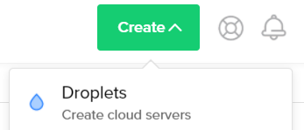

* Select the marketplace, select wordpress droplet image and cpu type

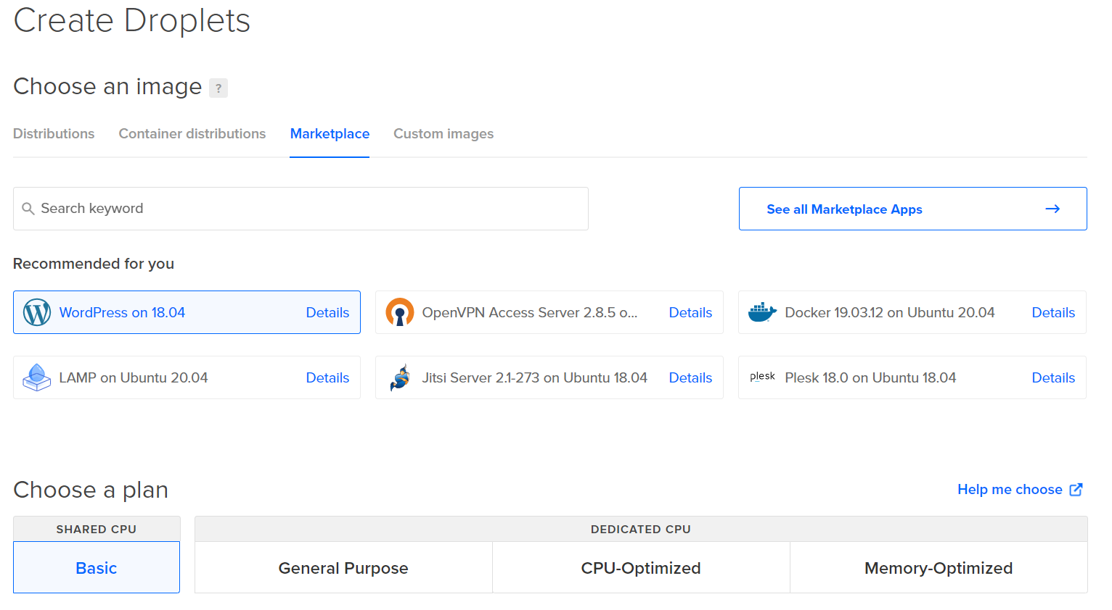

* Choose a datacenter region

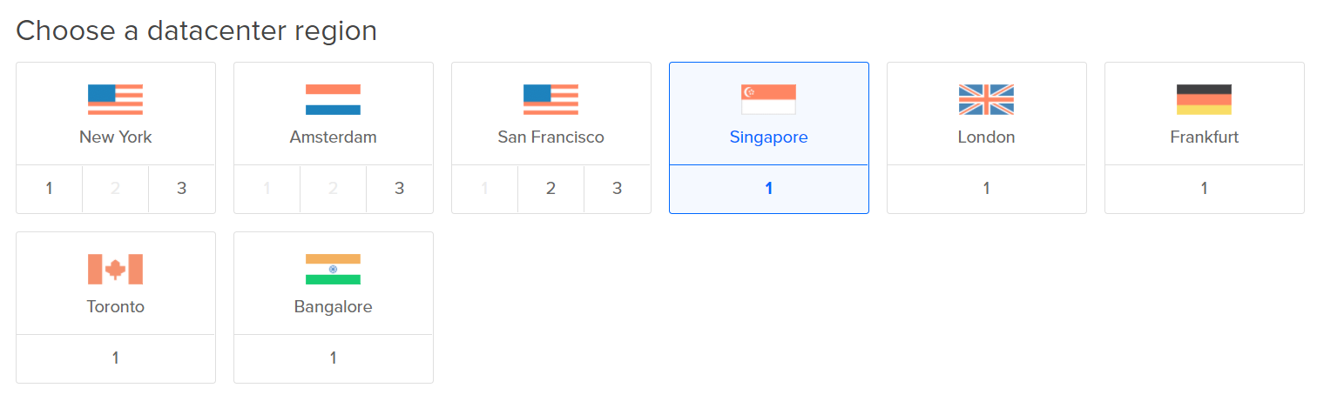

* Select ssh or password authentication type

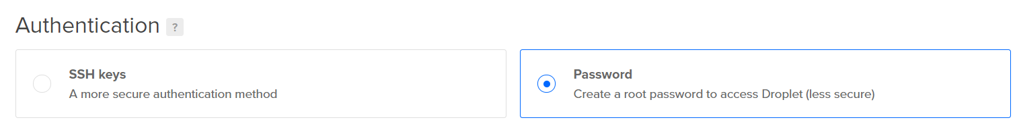

* Finalise droplet information and tag

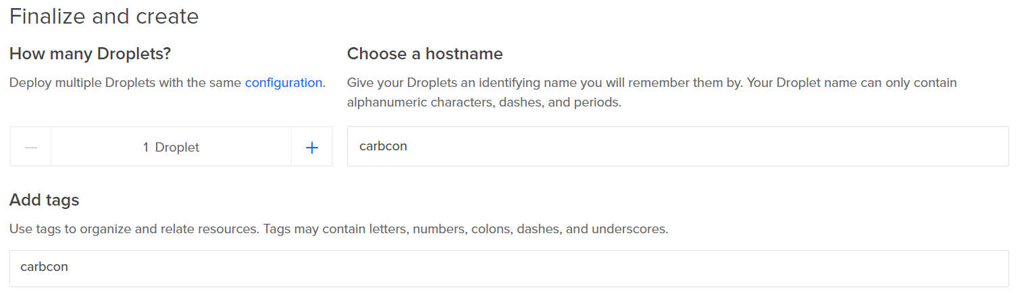

* After the droplet creation finished install the wordpress by redirecting into droplet IP address